St Leonard’s College
2020 School Assessed Coursework

VCE Economics
Unit 3
Outcome 3: Australia and the World Economy

General Instructions

5 minutes reading time plus 50 minutes writing time
Write using a black or blue pen
Use the space provided
Write your name below
Do not remove this paper from the classroom
Task
Section A will consist of 5 multiple-choice questions worth 1 mark each
(5 marks)
Section B will consist of 3 short answer questions including questions with multiple parts (25 marks)
Total for Section A & B: 30 marks
The task contributes 30% to your total Unit 3 course grade
This task has been designed to allow achievement up to and including the highest level in the performance descriptors.

Name:

This page has been intentionally left blank

Question 1
Consider a change in the exchange rate from A$1 = US$0.75 to A$1 = US$0.70. The most likely cause of this change is
- Fewer international tourists visiting Australia
- An increase in the number of international students studying in Australia
- An increase in Australia’s interest rates relative to the rest of the world
- Stronger rates of economic growth in the United States

Question 2
Which of the following is likely to decrease Australia’s international competitiveness?

- A. Australia’s inflation rate rising from 2% to 1% over the past two years
- B. A rise in the growth of Australia’s Wage Price index over the past 2 years
- C. A rise in Australia’s labour productivity over parts of 2019
- D. A lower Australian Trade Weighted Index over the past 2 years

Question 3
Which of the following would be recorded as a debit in the capital and financial account?

A. Imported clothing is purchased by Australians.
B. An Australian financial institution pays interest to an American bank
C. An Australian mining firm sells coal to China.
D. An Australian financial institution lends money to an American bank

Question 4
The following table contains some data from a hypothetical country’s balance of payments. Using the relevant data, calculate the balance on the country’s current account.
 | $Billion (B)
Balance on merchandise trade | - 10
Services exports | 20
Services imports | 10
Net primary incomes | - 15
Net secondary incomes | -5

A. A deficit of $30B.
B. A deficit of $35B.
C. A surplus of $30B.
D. A deficit of $20B.

Question 5
A favourable movement in the terms of trade since late 2021 is unlikely to have been caused by:

- A. Higher prices received for iron ore exports
- B. Lower prices paid for Chinese imports
- C. An increase of supply of coal and iron ore on global markets
- D. Continuing high growth in the Chinese economy

Section B (25 marks)

Question 6 (6 marks)

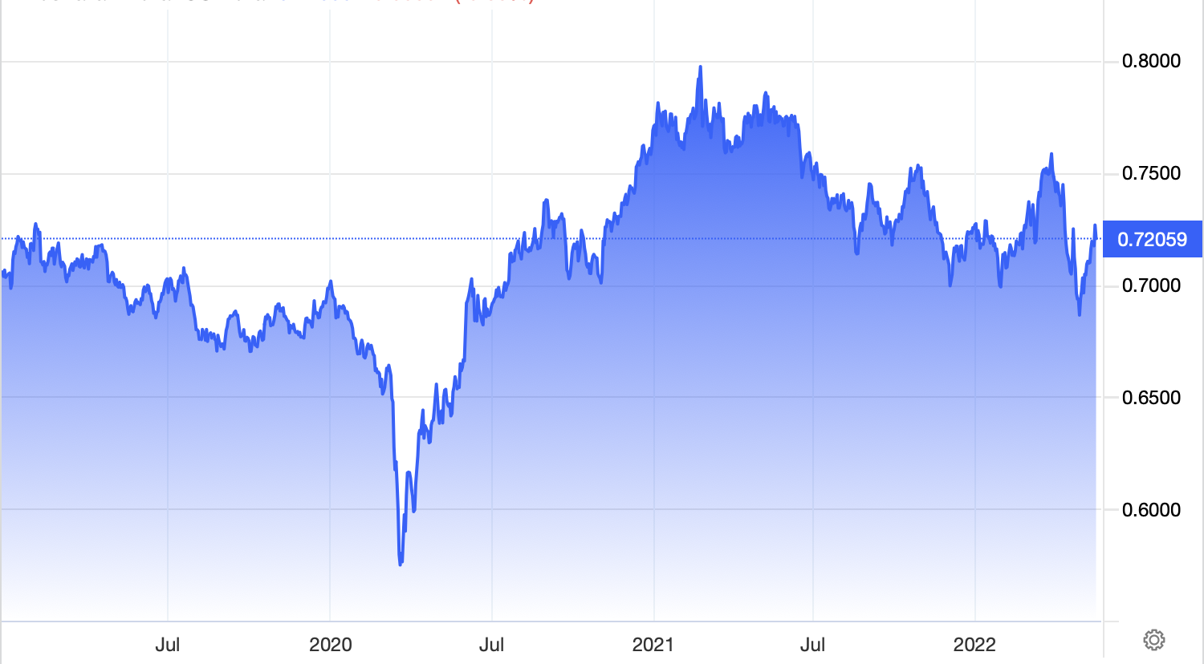

a) Describe ONE factor which may have caused the trend of Australia’s exchange rate since 2020 2 marks

________________________________________________________________________________________________________________________________________________________________________________________________________________________________________________________________________________________________________________________________________________________________________________________________________________________________________________________________________________________________________________________________________________________________________________________________________________________________________________________________________

b) Outline how the movement in the exchange rate identified in part a) above may influence inflation in 2022 2 marks
__________________________________________________________________________________________________________________________________________________________________________________________________________________________________________________________________________________________________________________________________________________________________________________________________________________________________________________________________________________________________________________________________________________________________________________________________________________________________________________________________________________________________________________________________________________________________________________________________________________________________________

c) Explain how a favourable movement in the Terms of Trade would impact the value of the Australian dollar 2 marks
__________________________________________________________________________________________________________________________________________________________________________________________________________________________________________________________________________________________________________________________________________________________________________________________________________________________________________________________________________________________________________________________________________________________________________________________________________________________________________________________________________________________________________________________________________________________________________________________________________________________________________

Question 7 ( 10 marks)

a. Outline the relationship between the current account and the capital and financial account 2 marks
________________________________________________________________________________________________________________________________________________________________________________________________________________________________________________________________________________________________________________________________________________________________________________________________________________________________________________________________________________________________________________________________________________________________________________________________________________________________________________________________________

b. Identify and 2 factors that might improve Australia’s international competitiveness. 3 marks
________________________________________________________________________________________________________________________________________________________________________________________________________________________________________________________________________________________________________________________________________________________________________________________________________________________________________________________________________________________________________________________________________________________________________________________________________________________________________________________________________

c) Discuss how the pursuit of trade liberalisation by the Australian government can influence unemployment and living standards in Australia. 5 marks
________________________________________________________________________________________________________________________________________________________________________________________________________________________________________________________________________________________________________________________________________________________________________________________________________________________________________________________________________________________________________________________________________________________________________________________________________________________________________________________________________________________________________________________________________________________________________________________________________________________________________________________________________________________________________________________________________________________________________________________________________________________________________________________________________________________________________________________________________________________________________________________________________________________________________________________________________________________________________________________________________________
________________________________________________________________________________________________________________________________________________________________________________________________________________________________________________________________________________________________________________________________________________________________________________________________________________________________________________________________________________________________________________________________________________________________________________________________________________________________________________________________________

Question 8 (9 marks)

a) Describe a cyclical factor that may have contributed to Australia’s current account surplus. 2 marks
________________________________________________________________________________________________________________________________________________________________________________________________________________________________________________________________________________________________________________________________________________________________________________________________________________________________________________________________________________________________________________________________________________________________________________________________________________________________________________________________________

b) Explain how each of the following are likely to have influenced the Balance on Goods and Services (BOGS) over the past year. 4 marks

i. The AUD depreciation
_________________________________________________________________________________________________________________________________________________________________________________________________________________________________________________________________________________________________________________________________________________________________________________________________________________________________________________________________________________________________________________________________________________________________________________________________________________________________________________________________________________________________________________________________________________________
ii. A favourable movement in the Terms of Trade (TOT) ________________________________________________________________________________________________________________________________________________________________________________________________________________________________________________________________________________________________________________________________________________________________________________________________________________________________________________________________________________________________________________________________________________________________________________________________________________________________________________________________________

c) Define net foreign debt and explain how an increase in net foregn debt would impact the current account balance.
3 marks
______________________________________________________________________________________________________________________________________________________________________________________________________________________________________________________________________________________________________________________________________________________________________________________________________________________________________________________________________________________________________________________________________________________________________________________________________________________________________________________________________________________________________________________________________________________________________________________________________________________________________________________________________________________________________________________________________________________________________________________________________________________________________________________________________________________________________________________________________________________________________________

End of assessment task
Extra space for writing
_______________________________________________________________________________________________________________________________________________________________________________________________________________________________________________________________________________________________________________________________________________________________________________________________________________________________________________________________________________________________________________________________________________________________________________________________________________________________________________________________________________________________________________________________________________________________________________________________________________________________________________________________________________________________________________________________________________________________________________________________________________________________________________________________________________________________________________________________________________________________________________________________________________________________________________________________________________________________________________________________________________________________________________________________________________________________________________________________________________________________________________________________________________________________________________________________________________________________________________________________________________________________________________________________________________________________________________________________________________________________________________________________________________________________________________________________________________________________________________________________________________________

_______________________________________________________________________________________________________________________________________________________________________________________________________________________________________________________________________________________________________________________________________________________________________________________________________________________________________________________________________________________________________________________________________________________________________________________________________________________________________________________________________________________________________________________________________________________________________________________________________________________________________________________________________________________________________________________________________________________________________________________________________________________________________________________________________________________________________________________________________________________________________________________________________________________________________________________________________________________________________________________________________________________________________________________________________________________________________________________________________________________________________________________________________________________________________________________________________________________________________________________________________________________________________________________________________________________________________________________________________________________________________________________________________________________________________________________________________________________________________________________________________________________

